Lab - Identify Relevant Threat Intelligence

Objectives
Part 1: Research MITRE CVEs
Part 2: Access the MITRE ATT&CK Knowledge Base
Part 3: Investigate Potential Malware

Background / Scenario
You have been hired as a Tier 1 Cybersecurity Analyst by XYZ, Inc. Tier 1 analysts typically are responsible for responding to incoming tickets and security alerts. In this lab, you will conduct threat intelligence research for several scenarios that have impacted XYZ, Inc. Each scenario will require you to access threat intelligence websites and answer questions regarding the threat encountered in the scenario.

Required Resources
● 1 PC with internet access

Instructions

Part 1: Research MITRE CVEs
The MITRE organization created the Common Vulnerabilities and Exposures (CVE) database in 1999 to identify, define, and catalog publicly disclosed cybersecurity vulnerabilities. It was endorsed by the National Institute of Standards and Technology (NIST) in 2002. The CVE database is now the standard method of registering and identifying vulnerabilities.
In this part, you will research the CVE program and use the CVE list to identify threats.

Step 1: Research the CVE website.
Go to https://cve.mitre.org and navigate to the About > Terminology page to answer the following questions.

Questions:
What is the CVE Program?
Type your answer here.
What is a CVE Numbering Authority (CNA)?
Type your answer here.
What is an Authorized Data Publisher (ADP)?
Type your answer here.
What is the CVE List?
Type your answer here.
What is a CVE Record?
Type your answer here.
What is a CVE ID?
Type your answer here.

Step 2: Research CVEs at the Cisco Security Advisories website.
Many security sites and software refer to CVEs. For example, the cisco.com website provides Cisco Security Advisories identifying vulnerabilities associated with Cisco products. In this step, you will refer to this website to identify a CVE ID.
a. Leave the cve.mitre.org website open. In another browser tab, do an internet search for Cisco Security Advisories and click the link to go to the tools.cisco.com web page.
b. This page lists all the currently known CVEs. For the Impact column, click the down arrow and uncheck everything except Critical, and then click Done.
c. Choose one of the advisories and answer the following questions about your selected advisory.

Questions:
What is the name of the advisory that you chose?
Type your answer here.
What is the CVE ID? You will use this ID in the next step.
Type your answer here.
d. You can either click the advisory to go to a details page or click the down arrow next to the advisory name to get more information.

Question:
Is there a workaround for the advisory you chose?
Type your answer here.

Step 3: Return to the CVE website and research more about your chosen Cisco CVE.
a. Navigate back to the website cve.mitre.org website, which should still be open in a browser tab.
b. Click Search CVE List to open up a search box.
c. In the search field, enter the CVE ID for the critical advisory you documented in the previous step. The CVE ID is in the following format: CVE-[year]-[id_number].

Question:
Briefly describe the vulnerability.
Type your answer here.

Part 2: Access the MITRE ATT&CK Knowledge Base
The MITRE Adversarial Tactics, Techniques & Common Knowledge (ATT&CK) Framework enables the ability to detect attacker tactics, techniques, and procedures (TTP) as part of threat defense and attack attribution. In this part, you will investigate the MITRE ATT&CK website to answer questions.

Step 1: Go to the MITRE ATT&CK website.
Navigate to the https://attack.mitre.org website.
The page displays an attack matrix for enterprises which identifies various tactics and the techniques used by threat actors. Tactics are the header column titles (e.g., Reconnaissance, Resource Developments, etc.) with Techniques listed below. A short phrase for each technique summarizes what a threat actor could do to execute an attack. Clicking the linked phrase will take you to a page for detailed information about the techniques and methods for mitigation.
Note: You may need to expand the width of your browser window to see all 14 tactics. Alternatively, you can hold down the Shift key and scroll your mouse wheel to shift the window left and right.
This matrix is an excellent place to come to learn more about different tactics and techniques threat actors use to compromise systems. Cybersecurity analysts regularly visit this site to research specific attacks and possible mitigations.

Step 2: Investigate the Reconnaissance tactic and the Phishing for Information tactic.
Use the MITRE ATT&CK page to answer the following questions.

Questions:
How many techniques are attributed to the Reconnaissance tactic?
Type your answer here.
Under Reconnaissance, click Phishing for Information and read the description. Briefly describe how a threat actor could gather reconnaissance information using phishing techniques?
Type your answer here.
Expand the dropdown menu under the Phishing for Information header or refer to the menu on the left. What are sub-techniques used when phishing for information?
Type your answer here.
What steps could you take to mitigate these techniques?
Type your answer here.

Step 3: Investigate the Command and Control tactic and Data Encoding technique.
Use the MITRE ATT&CK page to answer the following questions.
Note: Command and Control is the 12th tactic in the matrix. You may need to expand the width of your browser window to see it. Alternatively, you can hold down the Shift key and scroll your mouse wheel to shift the window left and right.

Questions:
How many techniques are attributed to the Command and Control tactic?
Type your answer here.
Under Command and Control, click Data Encoding and read the description. Briefly describe how a threat actor could use data encoding for command and control?
Type your answer here.
What could you do to mitigate this technique?
Type your answer here.

Step 4: Investigate the Impact Tactic
Use the MITRE ATT&CK page to answer the following questions.
Note: The Impact tactic is the last tactic on the far right of the matrix.

Questions:
How many techniques are attributed to the Impact tactic?
Type your answer here.
Under Impact, click Disk Wipe and read the description. Briefly describe the impact if a threat actor does a disk wipe?
Type your answer here.
What could you do to mitigate this technique?
Type your answer here.

Part 3: Investigate Potential Malware
There are a number of tools that a cybersecurity analyst can use to validate malicious software. In this part, you will investigate an IPS alert to see if it is malicious software.

Step 1: Generate a SHA256 hash for a suspicious file.
As a Tier 1 Cybersecurity Analysts, you have access to a Security Information Event Management (SIEM) system on your Linux management station. The SIEM just sent you an IPS alert referencing a local IP address of 10.8.19.101. You decide to examine the actual traffic identified in the alert by pivoting to Wireshark.
a. As you scroll through the various packet captures of IP address 10.8.19.101, you notice that a file was downloaded by the host as shown in the figure.
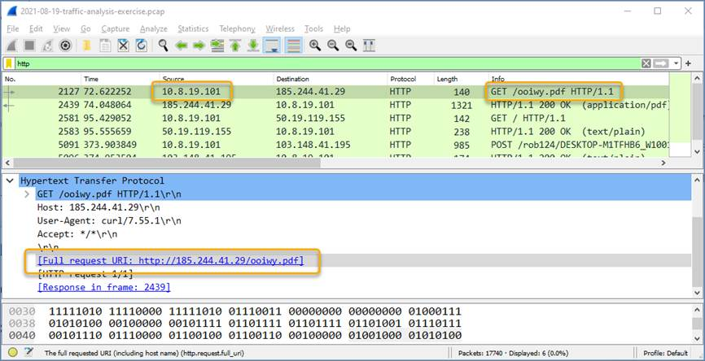
Blank Line, No additional information
b. You decide to export this file from Wireshark for malware analysis using the File > Export Objects > HTTP command and save the file with the name ooiwy.pdf.
c. Next you generate the SHA256 hash value of the saved file using the sha256sum command as shown.
[analyst@secOps ~]:~$ sha256sum ooiwy.pdf
f25a780095730701efac67e9d5b84bc289afea56d96d8aff8a44af69ae606404 ooiwy.pdf
Notice the SHA256 hash signature that was generated. This string can be validated in various file reputation sites to see if this the file is malware.

Step 2: Look up the hash at file reputation websites.
There are a number of file reputation sites that can be used to investigate this file. In this step, you will use Cisco's Talos website and virustotal.com.
a. Search for "Cisco Talos" and click the first link to access the Cisco Talos Intelligence Group website.
b. Locate the menus at the top and over the Reputation Center to dropdown a submenu. Click the link for the Talos File Reputation search page.
c. Copy the highlighted SHA hash value from the previous step and paste it into the search window. Click the “I’m not a robot” checkbox, and then click Search.
d. Review the information for this file.

Questions:
What is the Talos Weighted File Reputation Score? Is that good or bad?
Type your answer here.
e. Search for and navigate to the VirusTotal website.
f. Click Search, paste the SHA256 hash in the field, and then press Enter. The page displays all the security vendors that have identified this file as malicious (on the left) and the names this companies use to identify the malicious file.
g. Notice the column headings DETECTION, DETAILS, RELATIONS, BEHAVIOR, and COMMUNITY. Use the information on the DETAILs page to answer the following questions.

Questions:
When was this file created?
Type your answer here.
What other names is the file known by other than ooiwy.pdf?
Type your answer here.
What is the target machine?
Type your answer here.
End of document

